

Data Security Envisioning Workshop
04-Module Delivery Guide-Insider Risk Discovery
v8.5 - January 2026
Contents
Disclaimer 3
Version history 4
We look forward to your feedback! 5
1 Introduction 6
1.1 Objectives 6
1.2 Delivery guidance 6
1.3 Scoping 7
1.4 Estimated partner effort 7
1.5 Tools and services used 7
1.6 Modular setup, mandatory and optional activities 8
1.6.1 Insider Risk Analytics 10
1.6.2 Insider Risk Management policies 10
2 Activity details 12
2.1 Step 1 - Kick-off meeting 12
2.2 Step 2 - Acquire and assign licenses 12
2.3 Step 3 - Setup and configuration 13
2.3.1 Assign user permissions and roles 13
2.3.2 Enabling Insider Risk Analytics 14
2.3.3 Configure Insider Risk Management settings 17
2.3.4 Scenario—General Data leaks 18
2.3.5 Scenario—General Data leaks with Data Loss Prevention trigger 22
2.3.6 Scenario—Data theft by departing users 25
2.4 Step 4 - Analyze the findings 35
2.4.1 Prepare for analysis—exporting the reports and log files 36
2.4.2 Analyzing discovery findings log files for privacy and regulatory risks 40
2.5 Step 6—Decommission 43
Instructions 1 - Enable device indicators 48
1.1 Endpoint requirements 48
1.2 Onboarding devices 48
Instructions 2 - Enable Data Loss Prevention triggering 52

Disclaimer
The Data Security Envisioning Workshop provides a summary of an organization’s data protection and compliance stature and recommendations to improve data protection and compliance.
The information, results, and scoring provided through the Data Security Envisioning Workshop are recommendations and provided for general informational purposes only. They do not constitute legal advice, certifications, or guarantees regarding regulatory compliance; it is up to each organization to evaluate the effectiveness of these recommendations in their respective regulatory environment prior to implementation. Organizations should consult with their own legal professionals to determine how standards or regulations apply to their organization and how to best ensure compliance.
We hope the Data Security Envisioning Workshop helps identify technologies and additional steps that organizations can implement to simplify their compliance efforts.
MICROSOFT MAKES NO WARRANTIES, EXPRESS, IMPLIED, OR STATUTORY, AS TO THE INFORMATION IN THIS Data Security Envisioning Workshop. Microsoft disclaims any conditions, express or implied, or other terms that use of the Microsoft products or services will ensure the organization’s compliance with regulations or standards. This Data Security Envisioning Workshop toolkit is provided “as-is.” Information and recommendations expressed in the Data Security Envisioning Workshop toolkit may change without notice.
The Data Security Envisioning Workshop toolkit does not provide the user with any legal rights to any intellectual property in any Microsoft product or service. Use of the tool is for internal, reference purposes only; however, Microsoft partners may distribute the Data Security Envisioning Workshop toolkit to their customers for such customers’ internal, reference purposes only. Any distribution of the Data Security Envisioning Workshop toolkit by a Microsoft partner to its customers must include terms consistent with those set forth in this disclaimer.
© 2026 Microsoft. All rights reserved.

Version history
Version | Author | Changes | Date
3.0 | François van Hemert | First published modular release | January 2021
3.1 | François van Hemert | Updated version number to align with kit, no changes. | February 2021
3.1.1 | François van Hemert | Updates to align with new functionality, included AIP Scanner preview (AIP Analytics audit logs to Activity Explorer) | April 2021
4.0 | François van Hemert | Workshop split, update to align with new narrative, rebranding, updates to guidance and update to latest product versions. | July 2021
4.1 | François van Hemert | Added reference to Privacy Risk Management module, updated Priva branding. | January 2022
4.2 | François van Hemert | Purview branding update, step-by-step guidance update to align with changes M365. | July 2022
4.2.2 | Jim Banach | Update to align with current product features and functionality (evergreen)  Updated guidance for data theft by departing user policy. | January 2023
6.0 | François van Hemert | Workshop merge, align with FY24 solution play, focus on Data Security. | August 2023
6.5 | François van Hemert | Update step guidance, align with FY25 solution play | July 2024
6.6 | François van Hemert | Update to align with the new Microsoft Purview Portal | October 2024
7.0 | François van Hemert | Updated for additional module on Generative AI  Updated guidance on optional and mandatory activities | January 2025
7.1 | François van Hemert | Version number update, no further changes | May 2025
8.0 | François van Hemert | Update to align with current product features and functionality (evergreen), update name, update branding. | July 2025
8.5 | François van Hemert | Update to align with current product features and functionality (evergreen) | January 2026

We look forward to your feedback!
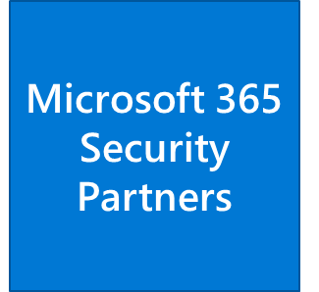
Thank you for your continued trust and partnership. The resources within this toolkit will be iteratively improved upon based on product releases as well as direct feedback from delivered engagements. We encourage you to provide feedback to help us improve our products and toolkits.
Please share your feedback and questions via our Engagement feedback form that can be found at: https://aka.ms/SCIEngagementsFeedback.

Introduction
This document contains delivery guidance that will extend the Automated Discovery Process to identify insider risks within the customer’s organization.
The outcome and findings of this activity will be merged into the overall findings and recommendations that will be presented at the end of the Data Security Envisioning Workshop.

Objectives
The objectives for this activity are:
- Analyze user behavior for risky activity.
Identify accidental oversharing of information outside the organization or data theft with malicious intent.
- Understand how to mitigate identified risks.
Help customers to better understand, prioritize, and mitigate these insider risks.
- Provide recommendations and define next steps.
Recommendations and next steps based on the findings from this activity will be rolled up into the overall Data Security Envisioning Workshop close-out presentation.

Delivery guidance
This document is an integral part of the overall delivery guidance for the Data Security Envisioning Workshop. When delivering the Data Security Check-Insider Risk Discovery, follow the guidance provided in the <00-Master Delivery Guide> and when instructed, engage in the supplemental activities outlined in this guide.
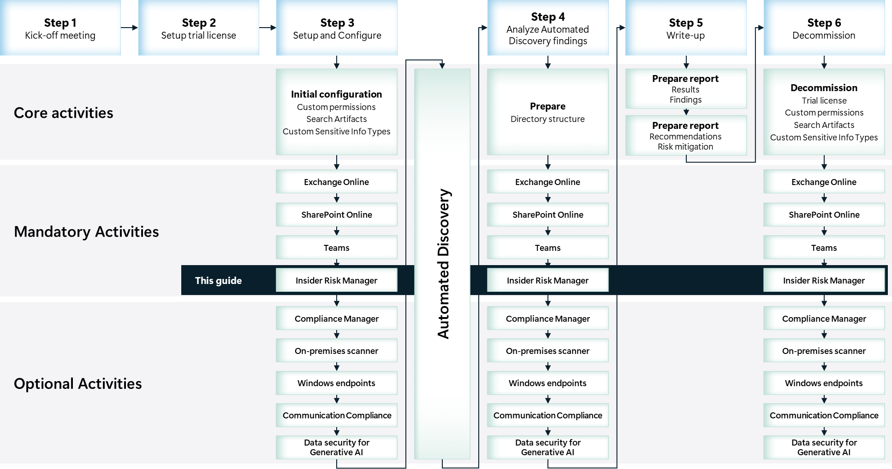

Scoping

In scope
The scope of this activity includes:
- Set up and configuration of Insider Risk Management.
- Enable and run Insider Risk Analytics.
- Enable and run additional scenarios such as General Data leaks and Data theft by departing users.
- Analyze and document findings.

Estimated partner effort
The table below provides a high-level estimate of the additional partner effort for the activities described in this guide. The numbers provided are to be considered indicative and can change because of customization of the delivery schedule and the individual activities.
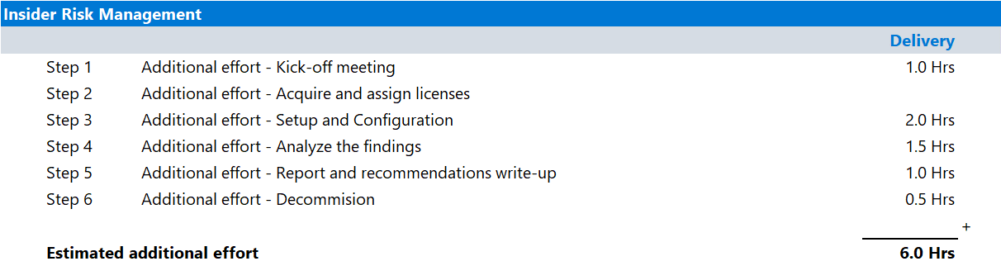

Tools and services used

Overview
The Data Security Check Automated Discovery process leverages Insider Risk Management to identify risks originating from organizational insiders.
Insider Risk Management is a Microsoft 365 solution that enables customers with the functionality needed to identify, investigate, and take action to address insider risks within their organization. With focused policy templates, comprehensive activity signaling across the Microsoft 365 service, and a flexible workflow, customers can use actionable insights to quickly identify and resolve risky behavior. Risk analysts in the customer’s organization can take appropriate actions to make sure users are compliant with the organization's compliance standards.

Product information
For more information on Insider Risk Management, refer to:
- Learn about insider risk management.

Functionality used by the Data Security Check
The Data Security Check will leverage Insider Risk Management for the discovery of:
- General Data leaks. Protecting data and preventing data leaks is a constant challenge for most organizations, particularly with the rapid growth of new data created by employees, devices, and services. Employees are empowered to create, store, and share information across services and devices that make managing data leaks increasingly more complex and difficult. With an assigned Microsoft Purview Data Loss Prevention (DLP) policy, built-in or customizable triggering events, this template starts scoring real-time detections of suspicious SharePoint Online data downloads, file and folder sharing, printing files, and copying data to personal cloud messaging and storage services.
- Data theft by departing users. For employees leaving the organization, there are specific risk indicators that are typically associated with data theft. For the discovery of Data theft by departing users, the Automated Discovery activity prioritizes these indicators and focuses detection and alerts to this risk area. Data theft by departing users may include downloading files from SharePoint Online, sending files though Exchange Online, copying files to portable devices such as USB drives, printing files, and copying data to personal cloud messaging and storage services near their employment resignation and end dates. By using either the Microsoft HR connector or the option to automatically check for user account deletion in Microsoft Entra ID for the organization, this template starts scoring for risk indicators relating to these activities and how they correlate with user employment status.

Modular setup, mandatory and optional activities
Insider Risk Discovery is designed in a modular setup and contains both mandatory and optional activities:
- Mandatory activities are required to successfully deliver Insider Risk Discovery and must be delivered. The mandatory activities include:
  - Enabling supporting services, assigning user permissions, and implementing required configuration.
  - Enabling Insider Risk Analytics.
  - Enable the General Data Leaks scenario or the Data theft by departing users scenario.
  - Analyzing and documenting findings.
- Optional activities can be added to the engagement depending on customer needs and requirements. The optional activities that can be added to the engagement are:
  - Implement both the General Data Leaks scenario and the Data theft by departing users scenario.
  - Enable additional indicators and triggers for Insider Risk Management scenarios such as:
    - Device indicators
    - Data Loss Prevention triggers
    - Simulated HR connector
The illustration below provides a high-level overview of the activities that are part of the Insider Risk Discovery module.
Mandatory activities are outlined in blue, while optional scenarios are filled with either yellow or blue, depending on whether they can be entirely omitted or are part of a group where at least one must be delivered. For more details, refer to the upcoming paragraphs.
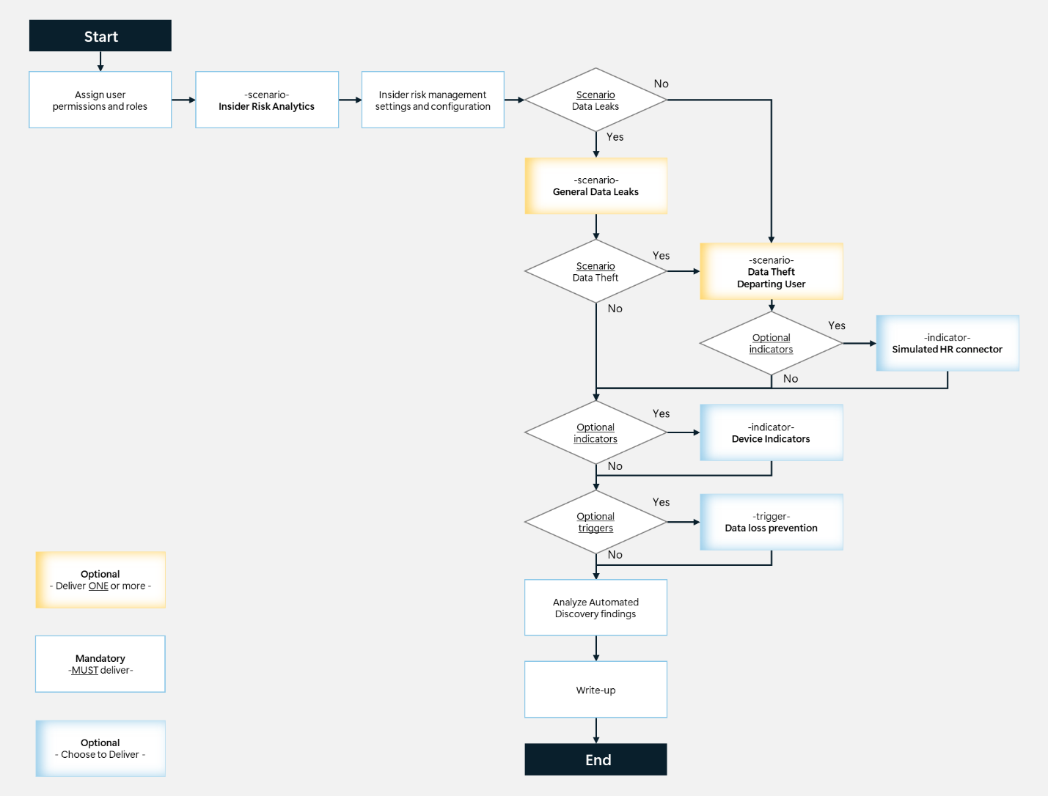

Insider Risk Analytics
Insider Risk Analytics enables a customer to conduct an evaluation of potential insider risks in their organization without configuring any insider risk policies. This evaluation can help the organization identify potential areas of higher user risk and help determine the type and scope of Insider Risk Management policies that should be considered for future implementation. This evaluation may also help determine the need for additional licensing or future optimization of existing policies. Analytics scan results may take up to 48 hours before insights are available as reports for review.

Insider Risk Management policies
Insider risk policies define the type of risk activities that can be detected and investigated.
Insider Risk Management comes with a set of out-of-box templates with pre-defined policy conditions that define the types of risk indicators and risk scoring model used by the policy. Each policy template is based on specific (set of) indicators that correspond to specific triggers and risk activities.
The objective for the Data Security Envisioning Workshop Insider Risk Discovery module is to implement one or more out-of-box Insider risk policy templates such as the General Data leaks policy or the Data theft by departing users policy.
The guidance provided in the Step 3 - Setup and configuration will implement the Insider Risk Management policies as discussed in paragraph 1.5 - Tools and services used with a default set of Policy indicators and Triggering events. Additional guidance is provided to help implement optional indicators and triggers that will enrich the detection capabilities of the policy. Depending on customer requirements and interest, these additional indicators and triggers can be enabled and configured while delivering Insider Risk Discovery.

Additional indicators and triggers for <General Data leaks>
The General Data leaks policy by default only uses Office indicators along with Cumulative exfiltration detection and Risk score boosters and can optionally be enhanced with Device indicators and Data Loss Prevention triggers.

Primary indicators
- Types: Office indicators, Cumulative exfiltration detection, Risk score boosters.
- Enabled: Yes.
- Applies to: Exchange email, SharePoint sites, OneDrive for Business and Teams.

[Optional] Device indicators
- Enabled: Optional, per customer request.
- Applies to: Endpoint devices with Windows 10 Build 1809 or higher or Windows 11.
- Requirements: Devices must first onboard to the Microsoft Purview portal.

[Optional] High severity Data Loss Prevention policy match
- Enabled: Optional, per customer request.
- Applies to: Users included in the Data Loss Prevention policy.
- Requirements: Definition of Sensitive Info Types, creation of a Data Loss Prevention policy.

Additional indicators and triggers for <Data theft by departing users>
The easiest way to implement the Data theft by departing users policy is to enable User account deletion in Microsoft Entra ID as a policy trigger and enable the Office indicators, Cumulative exfiltration detection, and Risk score boosters. Optionally the policy can be enhanced by enabling the Device indicator and the (simulated) HR connector.
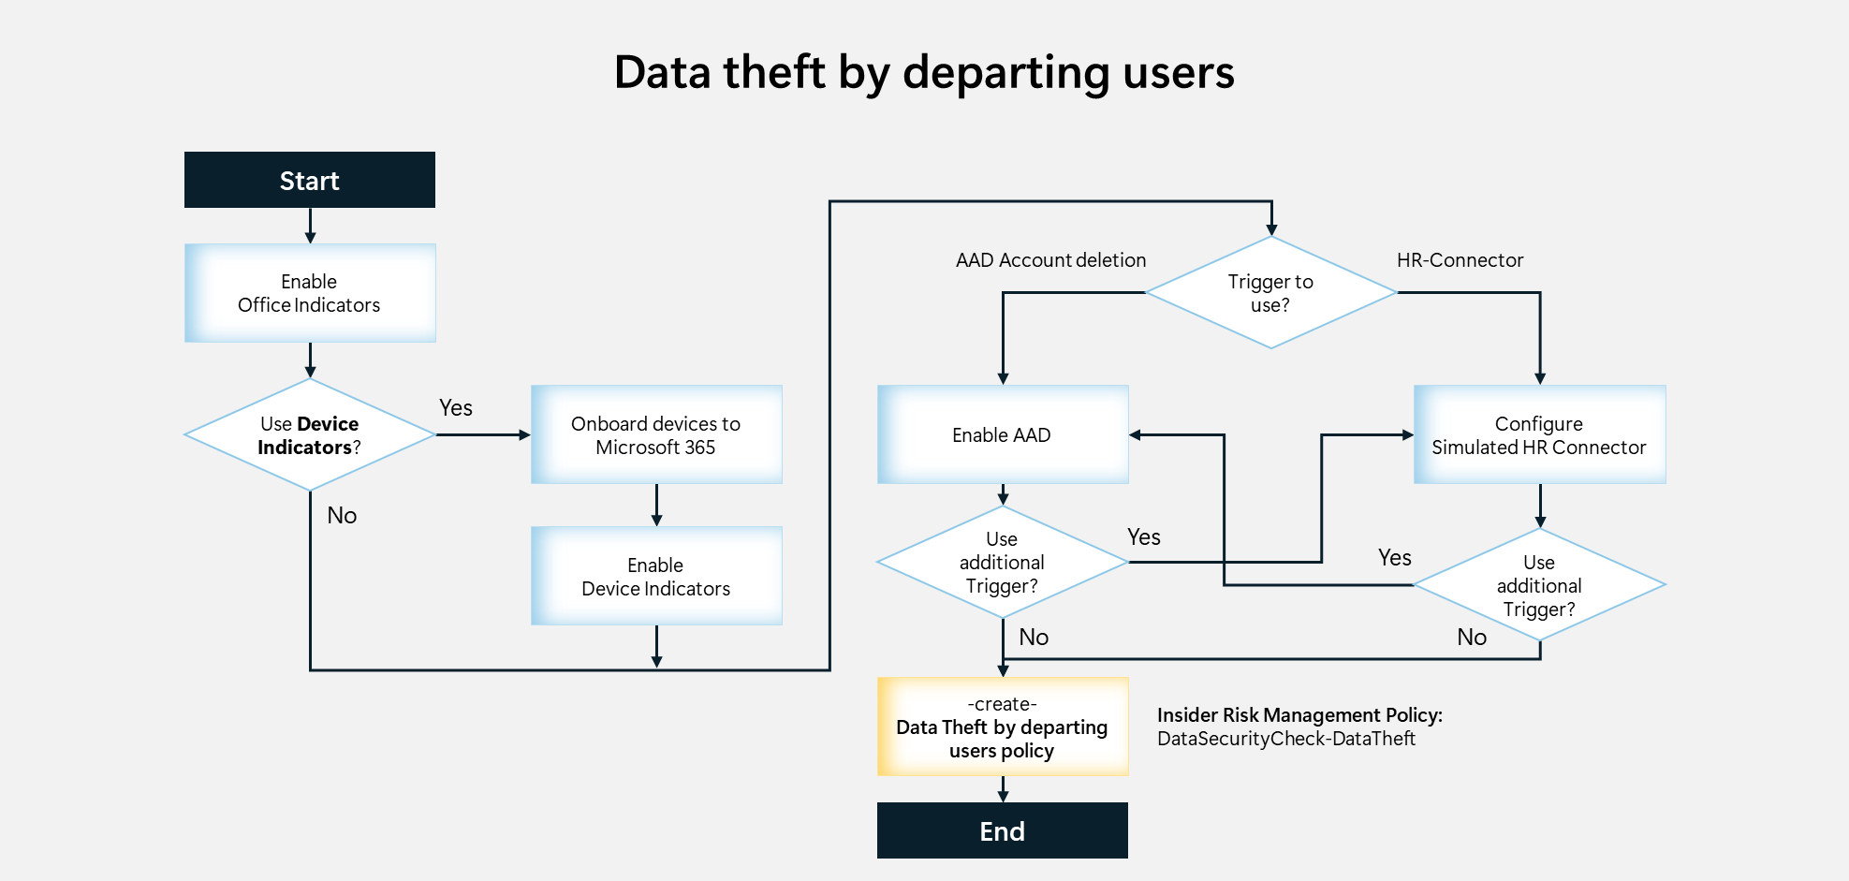

Primary indicators
- Types: Office indicators, Cumulative exfiltration detection, Risk score boosters.
- Enabled: Yes.
- Applies to: Exchange email, SharePoint sites, OneDrive for Business and Teams.

[Optional] Device indicators
- Enabled: optional, per customer request.
- Applies to: endpoint devices with Windows 10 Build 1809 or higher or Windows 11.
- Requirements: devices must first onboard to the Microsoft Purview portal.

[Optional] HR-Connector
- Enabled: optional, per customer request. Can replace or be added to the Entra integration.
- Applies to: employees leaving the organization or disgruntled employees.
- Requirements: Installation of the HR connector (simulation).

Activity details

Step 1 - Kick-off meeting

Guidance
Follow the guidance for the Kick-off meeting provided in <00-Master Delivery Guide> and add an additional section to the meeting(s) to discuss:
- Insider Risk Discovery by using the Insider Risk Management tool.
- The Insider Risk Management policies to implement as part of the Insider Risk Discovery module.
- The users to include in the discovery activity.
- The privacy aspects of Insider Risk Management.
- Additional Policy triggers and indicators to enable.
The <40-Pre-engagement and Kickoff deck> contains optional slides with speaker notes that can be used to facilitate the discussion.

Supporting materials
- <40-Pre-engagement and Kickoff deck>
Note
The <40-Pre-engagement and Kickoff deck> is used during the Pre-engagement meeting and the Kick-off meeting. Instructions on how to update the slides are included as hidden slides in the deck.

Pre-requisites
The activities and guidance described in this step complement Step 1 - Kick-off meeting as described in the <00-Master Delivery Guide>. The activities should be merged and delivered as one.

Next step
- Return to the <00-Master Delivery Guide> and continue the guidance provided in Step 1 - Kick-off meeting.

Step 2 - Acquire and assign licenses
The required product licenses for this activity are included in the overall Data Security Check trial license that was deployed in Step 2 - Acquire and assign licenses described in <00-Master Delivery Guide>. No additional (trial) licenses are required.

Step 3 - Setup and configuration

Guidance
This step will provide guidance on how to enable the following scenarios with Insider Risk Management:
- Insider Risk Analytics
- General Data leaks
- Data theft by departing users
The mandatory Insider Risk Analytics scenario will be implemented by default followed by one or both optional scenarios depending on customer interest and opportunity.
The partner should work with the customer to understand the privacy impact of deploying these technologies in a short evaluation mode via the engagement, and if any exist, ensure appropriate safeguards are in place to protect the users.

Background reading
For more information refer to:
- Get started with Insider Risk Management
- Learn about Insider Risk Management

Pre-requisites
Prior to starting the activities in this step, the following mandatory Data Security Check activities as described in <00-Master Delivery Guide> should be completed:
- Step 1 - Kick-off meeting
- Step 2 - Acquire and assign licenses
- Step 3 - Setup and configuration

Assign user permissions and roles

Guidance
There are multiple role groups used to configure permissions to manage Insider Risk Management features (refer to Assign permissions in Insider Risk Management for more information). For the Data Security Check activity, all team members will be assigned to the Insider Risk Management role group. This role group contains all the Insider Risk Management permission roles and provides the easiest way to quickly get started with Insider Risk Management.
Note
In a production setting, it is recommended to assign users to specific role groups to manage different sets of Insider Risk Management features.

 Important
Assigning all Data Security Check team members to the Insider Risk Management group will, in some regions of the world, be subject to privacy laws and impacted by labor laws and regulations. It is recommended to discuss this with the customer prior to implementation.

Objective(s)
- Assign the Data Security Check team members to appropriate roles.

Background reading
For more information refer to:
- Assign permissions in Insider Risk Management

Instructions
- Browse to the Microsoft Purview portal at https://purview.microsoft.com/ and log in with your Tenant Admin credentials or an account that is assigned the global admin role.
- In the navigation bar on the left side, click on Settings.
- On the Settings card, expand Roles and scopes.
- Below Roles and scopes, click on Role groups.
- On the Role groups for Microsoft Purview Solutions page, search for Insider Risk Management.
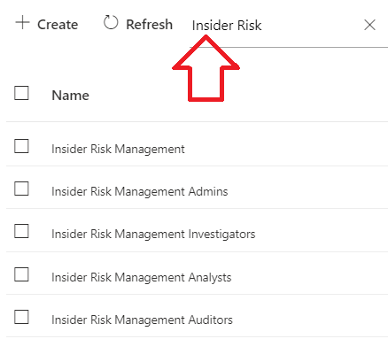
- Click on Insider Risk Management.
- On the Insider Risk Management flyout, click Edit.
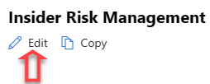
- On the Edit Members of the role group page, click on Choose Users.
- On the Choose members fly-out, select all the Data Security Check team members that should be assigned the Insider Risk Management role.
- On the Choose users pane, click Select.
- On the Edit Members of the role group pane, click Next.
- On the Review the role group and finish page, click Save.
- Click Done.

Enabling Insider Risk Analytics

Guidance
Insider Risk Analytics enables an organization to conduct an evaluation of potential insider risks without the need to configure insider risk policies. This evaluation can help the organization identify potential areas of higher user risk and help determine the type and scope of Insider Risk Management policies the organization could consider configuring.
Insider Risk Analytics scans for risk activity events from several sources to help identify insights into potential areas of risk. Depending on the customer’s current configuration, analytics looks for qualifying risk activities in the following areas:
- Microsoft 365 audit logs: Included in all scans, this is the primary source for identifying most of the potentially risky activities.
- Exchange Online: Included in all scans, Exchange Online activity helps identify activities where data in attachments are emailed to external contacts or services.
- Microsoft Entra ID: Included in all scans, Microsoft Entra ID history helps identify risky activities associated with users with deleted user accounts.
- Microsoft 365 HR data connector: If configured, HR connector events help identify risky activities associated with users that have resignation or upcoming termination dates.
The first time Insider Risk Analytics is enabled, it will provide scan results for one day. For the Data Security Check, Insider Risk Analytics will run a minimum of two weeks and the results of the daily scans will be added to the insight reports.

Important
After Insider Risk Analytics is started, it can take up to 48 hours to detect and return risk activities.

Objective(s)
- Enable and run Insider Risk Analytics.

Background reading
For more information refer to:
- Step 3 (optional): Enable and view insider risk analytics insights
- Enable analytics in insider risk management

Instructions – verify pre-requisites
When opening the Insider Risk Management dashboard, a list of recommended actions will be presented and the applicable pre-requisites will be verified. Follow the instructions below to confirm the required services are enabled and necessary permissions are assigned.
- Browse to the Microsoft Purview portal at https://purview.microsoft.com/ and log in with Tenant Admin credentials or a user account that is a member of your Data Security Check team and has been assigned the appropriate permissions.
- In the navigation bar on the left side, click on Solutions.
- In the Solutions navigator, click on Insider Risk Management.
- On the Insider Risk Management solution card, click on Overview.
- On the Overview page, below <your name>, here are your top recommended actions, verify Turn on auditing and Get permissions to use insider risk management are not visible.
Your screenshot should look similar to the image below.
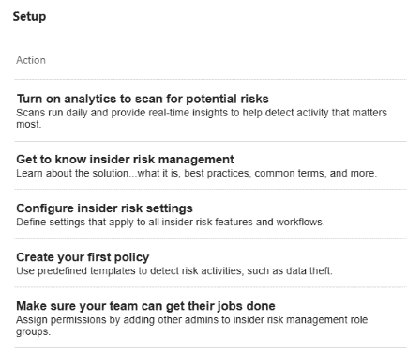
 Important
Do not continue if the pre-requisites are not in place but revisit the relevant sections in the <00-Master Delivery Guide> and use the provided guidance to enable auditing and assign the appropriate permissions.

Instructions – Turn on analytics to scan for potential risks
- On the Overview page, below <your name>, here are your recommended actions, click on Turn on analytics to scan for potential risks.
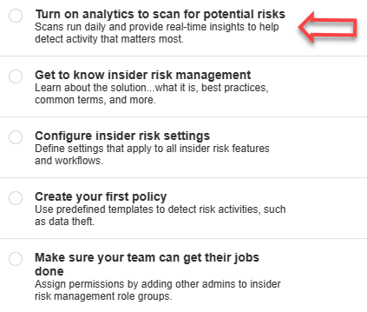
- On the Turn on analytics for potential risks fly out, click on Run scan.
- On the Analytics scan started fly out, click the X to close.
Note
Clicking <Run scan> will enable Insider Risk Analytics. When turned on, the analytics process will run daily and scan for recent risk activities. At the end of the Data Security Check, paragraph 2.5-Step 6—Decommission provides instructions on how to disable scan functionality.

 Important
The first analytics scan takes 48 hours to complete.

- Verify the Analytics scan is running by checking the Recommended actions section.
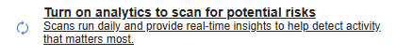
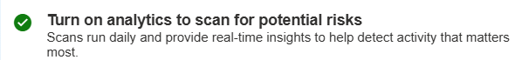
 Important
To safeguard user privacy, all user activity returned by scans is anonymized. No user details are included.

Configure Insider Risk Management settings

Instructions – confirm privacy settings
The Insider Risk Management solution provides a tenant level option to help customers facilitate internal governance at the user level. Protecting the privacy of users that have policy matches is important and the delivery partner should work with the customer to understand the privacy impacts of deploying these technologies and ensure appropriate safeguards are in place to protect the users.
Note
For the purposes of the Data Security Check, it is recommended that identity anonymization is enabled in order to manage the privacy implications of the Data Security Envisioning Workshop in the customer environment. More information about privacy settings can be found here: Manage username privacy in insider risk management.

- In the navigation bar on the left side, click on Settings.
- On the Settings card, below Solution settings click on Insider Risk Management.
- On the Insider risk management settings page, click on Privacy.
- In the Privacy section, verify Show pseudonymized versions of usernames is selected.
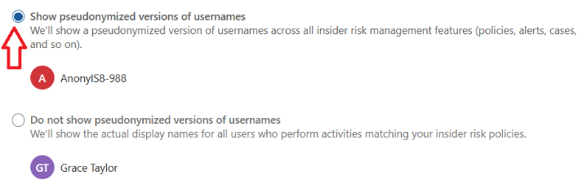
- Do not close or navigate away from the Settings dashboard

Instructions – choose policy indicators
- On the Insider risk management Settings page in the menu on the left, click on Policy indicators.
- In the Policy indicators section, expand the Office indicators section and enable Select All.
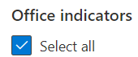
- On the Policy indicators page expand the Cumulative exfiltration detection section and enable select all.
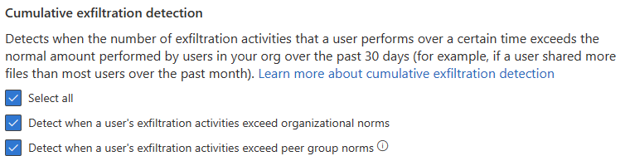
- On the Policy indicators page, expand the Risk score boosters and enable Select all.
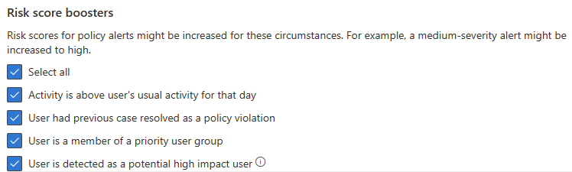
- Click on Save.

Scenario—General Data leaks

Guidance
The General Data leaks policy detects data leaks by any user included in the policy. Data leaks can range from accidental oversharing of information outside the customer’s organization to data theft with malicious intent.​
This paragraph describes the setup and configuration of the General Data leaks policy and includes one optional activity to add an additional indicator that enriches the monitoring scope. Depending on the customer requirements, partners can choose to add this additional activity to the scope of the Data Security Check activity.
The General Data leaks policy created in this paragraph will trigger on:
  - Users performing exfiltration activities that exceed the thresholds defined in the policy.
Additionally, instructions are provided to enable:
- The Device indicator to detect activity on endpoint devices.

Objective(s)
- Create an Insider Risk Management policy for the General Data leaks scenario.

Background reading
For more information and further customization, refer to:
- Data leaks

Create policy—General Data leaks

Instructions
- Browse to the Microsoft Purview portal at https://purview.microsoft.com/ and log in with Tenant Admin credentials or a user account that is a member of your Data Security Check team and has been assigned the appropriate permissions.
- In the navigation bar on the left side, click on Solutions
- In the Solutions navigator, click on Insider Risk Management.
- On the Insider Risk Management solution card, click on Policies.
- On the Policies page, click + Create policy.
- From the dropdown menu, select Custom policy.
- On the Choose a policy template page, in the template list, under Data Leaks, click on Data Leaks.
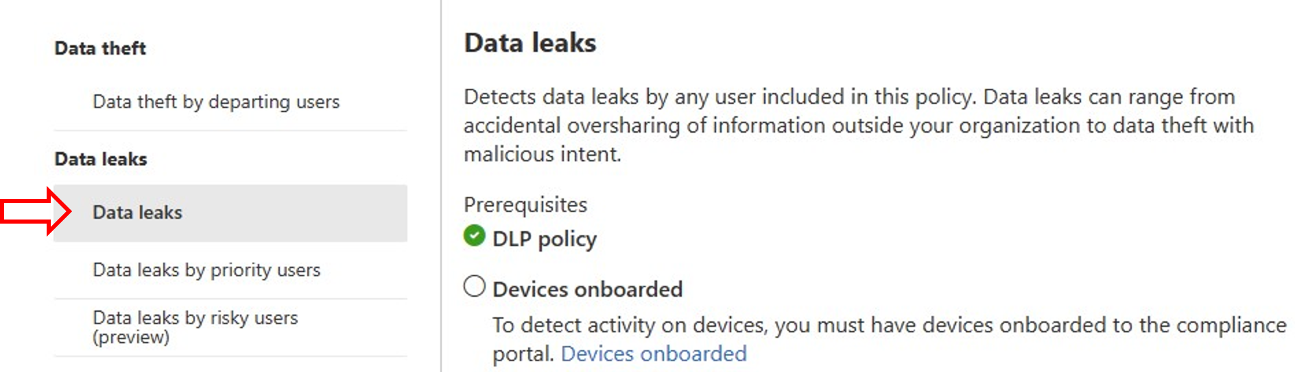
- Click Next.
- On the Name your policy page, name the policy DataSecurityCheck-DataLeaks and provide a meaningful description.
- Click Next.
- On the Choose users, groups & adaptive scopes page, select Specific users, groups and adaptive scopes
 Important
Users included in insider risk management policies must be assigned an appropriate (trial) license. Refer to Subscriptions and licensing for further details.

- On the Choose users, groups & adaptive scopes page, below Users, click on +Add users.
- On the Choose users fly-out, from the user list, select all users participating in the Data Security Check.
- Click Save.
- Back on the Choose users, groups & adaptive scopes page, click Next.
- If shown, on the Exclude users and groups (optional) page, click Next.
- On the Decide whether to prioritize content, select I don’t want to prioritize content…
- Click Next.
- On the Choose triggering event for this policy page, select User performs an exfiltration activity.
- Below Select which activities will trigger this policy, verify all selectable triggers are enabled.

Note
At this point not all of the available indicators can be enabled to trigger the policy because these indicators require additional installation or configuration steps. This guide includes optional activities to enable Device indicators that will allow for further policy enrichment. More information can be found at Configure policy indicators in insider risk management.

- Below Select which sequences will trigger this policy, verify all selectable sequences are enabled.
- Click Next.
- On the Choose thresholds for triggering events page, select Apply built-in thresholds (recommended).
- Click Next.
- On the Indicators page, verify that:
  - All Office indicators are selected.
  - All other indicators are deselected.
- Click Next.
- On the Detection options page, below Sequence detection verify Select all is selected.
- On the Detection options page, below Cumulative exfiltration detection verify Select all is selected.
- On the Detection options page, below Risk score boosters verify Select all is selected.
- Click Next.
- On the Choose threshold type for indicators page, verify Apply thresholds provided by Microsoft is selected.
- Click Next.
- On the Review settings and finish page, click Submit.
- On the Your policy was created page, below Send me the following emails, verify When a new policy generates its first alert is selected.
- click Done.
Note
After the policy is successfully submitted to the system it can take 24-48 hours before it becomes active.

[Optional] Enable Device indicators

Instructions
If the customer opts in to enabling Device indicators to further enrich detection capabilities of the General Data leaks policy, follow the instructions below.
- Follow the guidance in Instructions 1 - Enable device indicators at the end of this document to enroll devices into the Microsoft Purview compliance portal.

Update the Insider Risk Management policy to use device indicators
- Browse to the Microsoft Purview portal at https://purview.microsoft.com/ and log in with Tenant Admin credentials or a user account that is a member of your Data Security Check team and has been assigned the appropriate permissions.
- In the navigation bar on the left side, click on Solutions.
- In the Solutions navigator, click on Insider Risk Management.
- On the Insider Risk Management solution card, click on Policies.
- Click on the DataSecurityCheck-DataLeaks policy and on the fly-out, click on Edit policy.
- On the Choose a policy template pane verify devices are successfully onboarded.
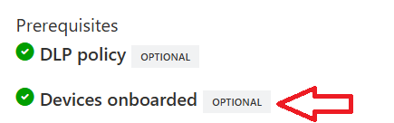
- Click Next.
- On the Name your policy page, click Next.
- On the Choose users, groups & adaptive scopes page, click Next.
- If shown, on the Exclude users and groups (optional) page, click Next.
- On the Decide whether to prioritize content page, click Next.
- On the Choose triggering event for this policy page, click Turn on indicators.
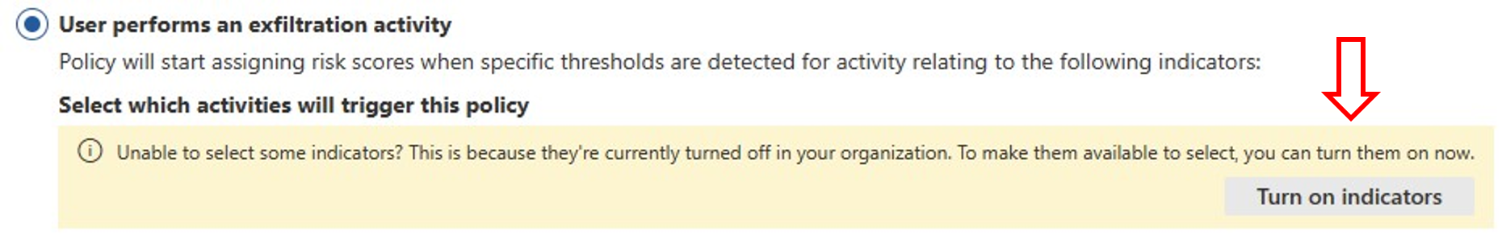
- On the Choose indicators to turn on page, below Device indicators, enable Select all.
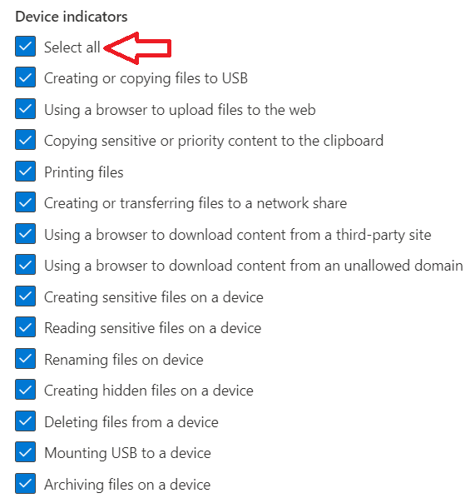
- Click Save.
- On the Choose triggering event for this policy page, below Select which activities will trigger this policy, select all activities.
- Below Select which sequences will trigger this policy, select all activities.
- Click Next.
- On the Choose thresholds for triggering events page, click Next.
- On the Indicators page, below Device indicators, enable Select all.
- Click Next.
- On the Detection options page, below Sequence detection, enable Select all.
- Click Next.
- On the Choose threshold type for indicators page, click Next.
- On the Review settings and finish page, click Submit.
- On the Your policy was created page, click Done.

Note
After the policy is successfully submitted to the system it can take 24-48 hours before it becomes active.

Scenario—General Data leaks with Data Loss Prevention trigger

Guidance
The General Data leaks policy detects data leaks by any user included in the policy. Data leaks can range from accidental oversharing of information outside the customer’s organization to data theft with malicious intent.​
This paragraph describes the setup and configuration of the General Data leaks policy and includes one optional activity to add an additional indicator that enriches the monitoring scope. Depending on the customer requirements, partners can choose to add this additional activity to the scope of the Data Security Check activity.
The General Data leaks policy created in this paragraph will trigger on:
- Data Loss Prevention policy match. Insider Risk Management will assign risk scores to a user if they perform an activity that matches a specified Data Loss Prevention policy.
Additionally, instructions are provided to enable:
- The Device indicator to detect activity on endpoint devices.

Objective(s)
- Create an Insider Risk Management policy for the General Data leaks scenario that triggers on Data Loss Prevention policy matches.

Background reading
For more information and further customization, refer to:
- Data leaks

Set up and configure Data Loss Prevention
Prior to configuring an Insider Risk Management General Data leaks policy that triggers on Data Loss Prevention policy matches, Sensitive Info Types and a Data Loss Prevention policy need to be created.
- Follow the guidance in Instructions 2 -Enable Data Loss Prevention triggering at the end of this document to create the DataSecurityCheck-DataLeaksDLP policy for the use of Data Loss Prevention triggers.

Create policy—General Data leaks

Instructions
- Browse to the Microsoft Purview portal at https://purview.microsoft.com/ and log in with Tenant Admin credentials or a user account that is a member of your Data Security Check team and has been assigned the appropriate permissions.
- In the navigation bar on the left side, click on Solutions
- In the Solutions navigator, click on Insider Risk Management.
- On the Insider Risk Management solution card, click on Policies.
- On the Policies page, click + Create policy.
- From the dropdown menu, select Custom policy.
- On the Choose a policy template page, below Data Leaks click on Data Leaks.
- Click Next.
- On the Name your policy page, name the policy DataSecurityCheck-DataLeaksDLP and provide a meaningful description.
- Click Next.
- On the Assign admin units page, click Next.
- On the Choose users, groups & adaptive scopes page, select Specific user, groups and adaptive scopes.
Important
Users included in insider risk management policies must be assigned an appropriate (trial) license. Refer to Subscriptions and licensing for further details.

- On the Choose users, groups & adaptive scopes page, click on +Add users.
- On the Choose users fly out, select all users participating in the Data Security Check.
- Click Add.
- On the Choose users, groups & adaptive scopes page, click on Next.
- On the Exclude users and groups (optional) page, click on Next.
- On the Decide whether to prioritize content page, select I don’t want to prioritize content...
- Click Next.
- On the Choose triggering event for this policy page, select User matches a data loss prevention (DLP) policy.
- Below User matches a data loss prevention (DLP) policy, select the previously created DataSecurityCheck-DLP-DataLeaks policy.
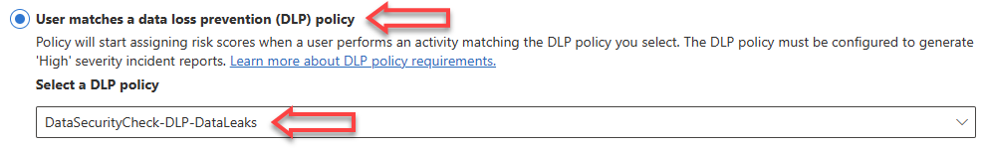
- Click Next.
- On the Policy indicators page, verify that at a minimum:
  - All Office indicators are selected.
- Click Next.
- On the Detection Options page below Sequence detection, verify Select all is checked.
- On the Detection Options page below Cumulative exfiltration detection, verify Select all is checked.
- On the Detection Options page below Risk score boosters, verify Select all is checked.
- click Next.
- On the Choose threshold type for indicators page, select Apply thresholds provided by Microsoft.

Note
Lowering the thresholds will generate more results and findings but will also increase the chance that false positives are reported. If possible, check the results of the Insider Risk Discovery process a couple of days after enablement and adjust the thresholds to a lower value if there are no or not enough results. Start with setting the values to half of the default and adjust further if needed.

- Click Next.
- On the Review settings and finish page, click Submit.
- On the Your policy was created page, below Send me the following emails, verify When a new policy generates its first alert is selected.
- On the Policy was created page, click Done.

Note
After the policy is successfully submitted to the system it can take 24-48 hours before it becomes active.

[Optional] Instructions—enable device indicators

Instructions
If the customer opts in to enabling device indicators to further enrich detection capabilities of the General Data leaks policy, follow the instructions below.
- If not already completed, follow the guidance in 1.2-Onboarding devices at the end of this document to enroll devices into the Microsoft Purview portal.

Update the Insider Risk Management policy to use device indicators
- Browse to the Microsoft Purview portal at https://purview.microsoft.com/ and log in with Tenant Admin credentials or a user account that is a member of your Data Security Check team and has been assigned the appropriate permissions.
- In the navigation bar on the left side, click on Solutions
- In the Solutions navigator, click on Insider Risk Management.
- On the Insider Risk Management solution card, click on Policies.
- Click on the DataSecurityCheck-DataLeaksDLP policy and on the fly-out, click on Edit policy.
- On the Choose a policy template page verify devices are successfully onboarded.

- Click Next.
- On the Name your policy page, click Next.
- On the Choose users, groups & adaptive scopes page, click Next.
- On the Exclude users and groups (optional) page, click Next.
- On the Decide whether to prioritize content page, click Next.
- On the Choose triggering event for this policy page, click Next.
- On the Choose thresholds for triggering events page, click Next.
- On the Indicators page, below Device indicators, enable Select all.
- Click Next.
- On the Detection Options page, below Sequence detection, enable Select all.
- Click Next.
- On the Choose threshold type for indicators page, click on Next.
- On the Review settings and finish page, click on Submit.
- On the Your policy was created page, click Done.

Note
After the policy is successfully submitted to the system it can take 24-48 hours before it becomes active.

Scenario—Data theft by departing users

Guidance
When users leave the organization, there are specific risk indicators associated with this event. The Data theft by departing users policy template uses exfiltration indicators for risk scoring and focuses on detection and alerts in this risk area. Data theft by departing users may include downloading files from SharePoint Online, printing files, and copying data to personal cloud messaging and storage services near their employment resignation and end dates. By using either the HR data connector or the option to automatically monitor for user account deletion in Microsoft Entra ID for the organization, this template starts scoring for risk indicators relating to these activities and how they correlate with user employment status.
The Data theft by departing users template can use two types of triggers to learn about employees leaving the organization:
- Account deletion: A user account that is deleted in Microsoft Entra ID triggers the policy.
- Information from connected HR system: The HR system informs Insider Risk Management through the HR connector about employees that have handed in their resignation.
This paragraph will provide configuration steps for both triggers. The delivery partner should, together with the customer, decide on implementing one or both triggers.
Additionally, instructions are provided to enable:
- The Device indicator to detect activity on endpoint devices.

Objective(s)
- Create an Insider Risk Management policy for the Data theft by departing users scenario.
- Implement a (simulated) HR connector.

Background reading
For more information and further customization, refer to:
- Data theft by departing users

[Optional] Setup and configure a (simulated) HR-connector

Guidance
Insider Risk Management supports importing user and log data from human resources platforms using the Microsoft 365 HR connector. The connector allows you to pull in human resources data from CSV files, including user termination and last employment dates. This data helps drive alert indicators in Insider Risk Management policies and is an important part of configuring full risk management coverage in the organization.
Implementing the Microsoft 365 HR connector is the recommended deployment approach. However, within the context of the Data Security Check, a full deployment may not be considered feasible. This section will therefore provide alternative solutions that are easier to implement and align better with the nature of the Data Security Check engagement.
To be able to implement the Data theft by departing users scenario for customers that do not wish to install a connection to the production HR system, this guide describes an alternative scenario that can be used to mimic the behavior of the HR connector.
The illustration below provides a high-level overview of the necessary steps to install a Microsoft 365 HR connector in a production environment and outlines the alternative approach discussed in this guide. For instructions on how to deploy the Microsoft 365 HR connector in a production environment, refer to Set up a connector to import HR data on Microsoft Learn.
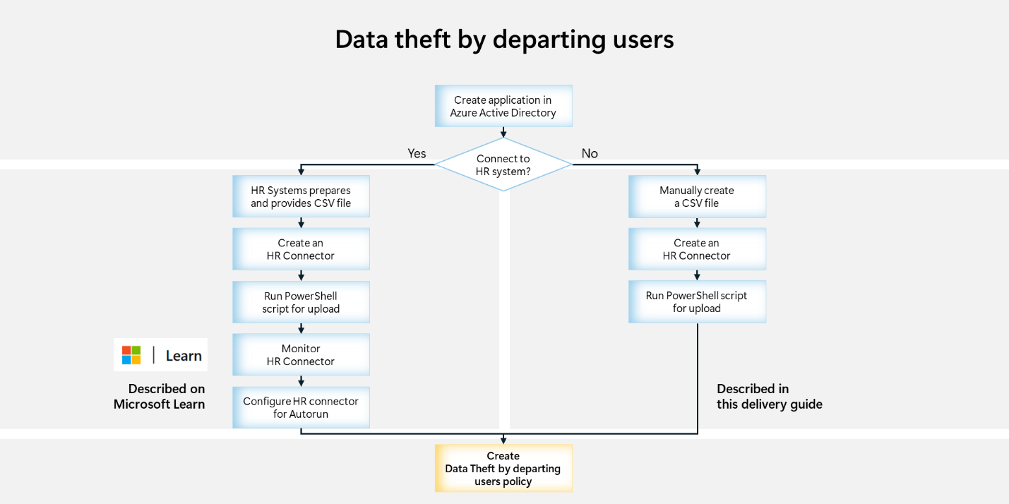
 Important
Adding live users to Insider Risk Management will have no effect on production access or provisioning for the identified users but may highlight these users’ actions to the administrators who are monitoring the insider risk function for a period of time. For this reason, in the engagement, a manually generated user list should not include legally sensitive users such as attorneys, a compliance or regulatory Officer, or persons who may be subject to current litigation notices.

In a production environment the HR system will, on regular intervals, produce a CSV file containing a list of departing employees. For the alternative approach we will manually generate this export file. The export file will be imported into Microsoft 365 by means of an Entra application and custom HR connector. The sections below describe the setup and configuration of these components.

Objective(s)
- Implement an alternative approach that simulates the Microsoft 365 HR connector.

Background reading
For more information, refer to:
- Step 4 (recommended): Configure prerequisites for policies
- Configure Microsoft 365 HR Connector
- Register an application in Microsoft Entra ID
- Set up a connector to import HR data

Instructions—Create application in Microsoft Entra ID
- Browse to the Microsoft Azure portal at https://portal.azure.com and log in with Tenant Admin credentials or a user account that has been assigned the appropriate permissions.
- Navigate to the Microsoft Entra ID pane by typing Entra in the search box for resources, services, and docs and then select Microsoft Entra ID.
- Expand Manage in the left-hand navigation pane and click on App registrations.
- Click on +New Registration.
- On the Register an application pane, type DataSecurityCheck-HRconnector as the Name for the application.
- Below Supported account types, select Accounts in this organizational directory only.
- Below Redirect URI (Optional) leave the default setting.
- Click on Register.
- On the User Risk Check HR overview pane
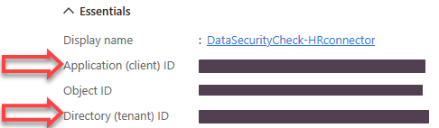
Write down the values for:
  - application(client) ID (also called the app ID or client ID).
  - Directory (tenant) ID (also called the tenant ID).

Application (client) ID | …………………………………………………………………………......................…
Directory (tenant) ID | …………………………………………………………………………......................…

- Expand Manage in the left-hand navigation pane and click on Certificates & secrets.
- On the DataSecurityCheck-HRconnector | Certificates & secrets pane, below Client secrets, click +New client secret.
- On the Add a client secret fly out, provide a meaningful description, and leave the Expiration date as default, Recommended 6 months.
- Click Add.
- On the DataSecurityCheck-HRconnector | Certificates & Secrets pane
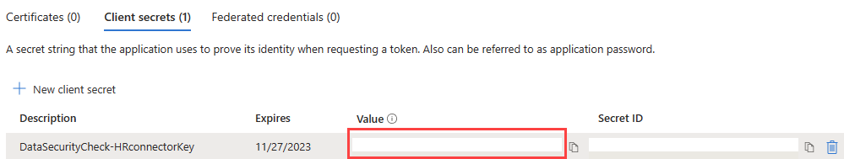
write down the value for the client secret.

Client secret - value | ………………………………………………………………………………………………

Instructions—Manually create the CSV file

Note
For the Data Security Check, we will simulate the HR connector by manually creating a CSV file with usernames that resemble an export from an HR system. For these users, an imaginary resignation date will be set that will trigger the Data theft by departing users scenario.

- Together with the customer, prepare a list of 10-50 users that will be part of the Insider Risk Management setup. Provide the email address for each user.
- Open the template Excel file <64-Employee Resignations Simulation Template> provided in the toolkit.
- Populate column A with the email addresses of the participating users.
Note
The template file comes with pre-configured values for <ResignationDate> and <LastWorkingDate>. Depending on the language used it might be required to update the date format. Refer to the example below for guidance.

Example
For US English use
=CONCATENATE(TEXT(NOW(),"yyyy-mm-dd"),"T00:00:00.000000Z")
For Dutch use:
=CONCATENATE(TEXT(NOW(),"jjjj-mm-dd"),"T00:00:00.000000Z")

Note
The <ResignationDate> and <LastWorkingDate> is pre-configured for midnight on the current day. If a different date is required, the formulas in Column B and C can be updated following the example below.

Example
To configure a resignation date 10 days from today:
=CONCATENATE(TEXT(NOW()+10;"yyyy-mm-dd");"T00:00:00.000000Z")

Note
The <ResignationDate> and <LastWorkingDate> must be specified using the ISO 8601 date and time format (yyyy-mm-ddThh:mm:ss.nnnnnnnZ). More information on ISO 8601 can be found at ISO 8601 date and time format.

- Delete any unused rows from the worksheet.
- In Excel, click on File -> Export -> Change File Type and choose CSV (Comma delimited) (*.csv).
- Click on Save a copy and save the CSV file to the local disk as HR-Export.
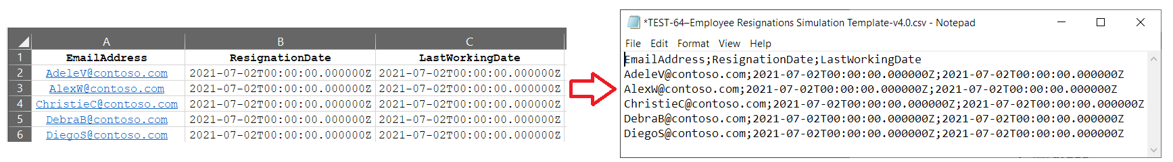

Note
CSV files do not support workbooks that contain multiple sheet. Before clicking OK verify the updated sheet is active.

Verify membership of the Data Connector Admin role group
The user creating the HR connector in the steps below must be assigned the Data Connector Admin role. This role is required to add connectors on the Data connectors page in the Microsoft Purview portal By default this role is added to multiple role groups. Refer to Roles and role groups in Microsoft Defender for Office 365 and Microsoft Purview and verify the account used is assigned the appropriate role.

Create the HR Connector
- Browse to the Microsoft Purview portal at https://purview.microsoft.com/ and log in with Tenant Admin credentials or a user account that is a member of your Data Security Check team and has been assigned the appropriate permissions.
- In the navigation bar on the left side, click on Settings.
- On the Settings card, expand Data connectors.
- Below Data connectors, click on All connectors.
- On the All connectors page, search for HR.
- Below Connector name, click on HR.
- On the HR page, click Add connector.
- On the Terms of Service page, click Accept.
- On the Add credentials for connecting to your data source page, type or paste the Application (client) ID for the Azure app (2) created in Step 1.
- Enter DataSecurityCheck-HRconnector as the name (2) of the connector.
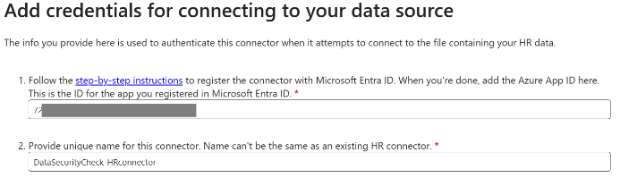
- Click Next.
- On the Choose the HR scenario you want to include page, select Employee Resignation.
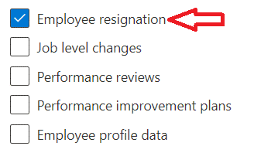
- Click Next.
- On the Decide whether to map data manually or from a sample file page, below What’s the format of file you would like to import? select .csv file – Comma delimited.
- Below How do you want to map your HR data?, select Upload a sample file (recommended).
- Click on Upload sample file.
- Open the previously saved comma delimited file HR-Export.csv.
- Click Next.
- On the Map the HR scenarios to the columns in your file page, click on Employee resignation to show the individual mapping.
- Below Microsoft 365 user email address, select EmailAddress.
- Below Date of resignation/termination (UTC time), select ResignationDate.
- Below Last employment date of the user (UTC time), select LastWorkingDate.
- Click Next.
- On the Review and finish page, click Finish.
- On the Your connector was created page, write down the Connector Job ID for future use.
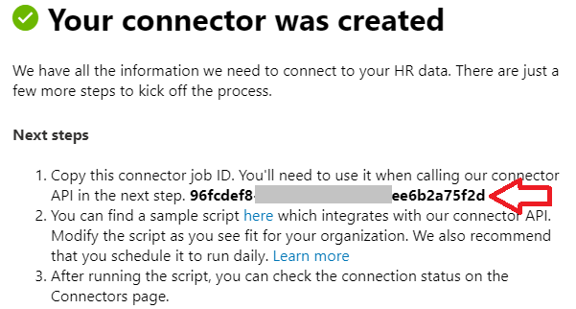
Connector Job ID | ……………………………………………………………………………………………………

- Click Done.

Instructions—Run PowerShell script to upload CSV file
- On the Data connectors overview page, on the My Connectors tab, click on the previously created connector DataSecurityCheck-HRconnector.
- On the DataSecurityCheck-HRconnector details page, click on Get sample script.
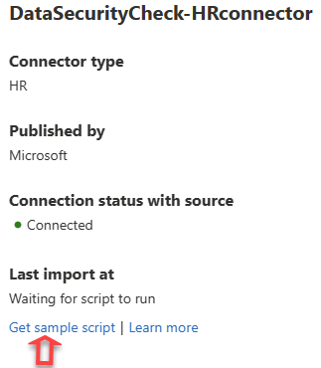
- On the Microsoft/m365-compliance-connector-sample-scripts GitHub page, click on copy icon to copy the script to your local clipboard.
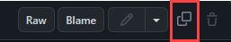
- On the local workstation, open Notepad and Paste the copied content to a new text file.
- Save the copied script to a text file named DataSecurityCheck-HRConnectorUpload.ps1.
Note
Before saving the file, carefully check and remove any unwanted content from the GitHub website at the end of the file. Tip: the last line should read ‘Send-ChunkedData $FilePath $RecordsPerCall’.

- On the local workstation, open a Windows PowerShell session with the Run as an administrator option.
- Change to the directory where the script was previously saved.
- Run the script with the following parameters:
.\DataSecurityCheck-HRConnectorUpload.ps1
-tenantId <tenantId>
-appId <Application (client) ID>
-appSecret <Client secret – value / Secret ID>
-jobId <jobId / connectorId>
-FilePath '<csvFilePath>'
DataSecurityCheck-HRConnectorUpload.ps1
-tenantId | Directory ID (also called the tenant ID), recorded in section:  Instructions—Create application in Microsoft Entra ID
-appId | Application (client) ID (also called the app ID or client ID), recorded in section: Instructions—Create application in Microsoft Entra ID
-appSecret | Client secret - value (also called the client secret), recorded in section: Instructions—Create application in Microsoft Entra ID
-jobId | Connector Job ID, recorded in section:
-FilePath | Full path to the CSV file created in section:  Instructions—Manually create the CSV file
Example
.\ DataSecurityCheck-HRConnectorUpload.ps1
-tenantId xxxxxxxx-xxxx-xxxx-xxxx-xxxxxxxxx
-appId xxxxxxxx-xxxx-xxxx-xxxx-xxxxxxxxx
-appSecret xxxxxxxxxxxxxxxxxxxxxxxxxxx
-jobId xxxxxxxx-xxxx-xxxx-xxxx-xxxxxxxxx
-FilePath 'c:\CC HR Connector\HR-Export.csv'
- Verify the script uploads the information from the CSV file successfully.
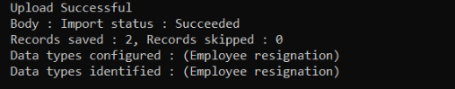
- Browse to the Microsoft Purview portal at https://purview.microsoft.com/ and log in with the user previously assigned to the Data connector admin role.
- In the navigation bar on the left side, click on Settings.
- On the Settings card, expand Data connectors.
- Below Data connectors, click on My connectors.
- For the DataSecurityCheck-HRconnector, verify the Connection status with source shows Connected.
Note
It will take around 24 hours after importing the CSV file before the Insider Risk machine learning technologies populate the user interface.

Create policy—Data theft by departing users

Instructions
- Browse to the Microsoft Purview portal at https://purview.microsoft.com/ and log in with Tenant Admin credentials or a user account that is a member of your Data Security Check team and has been assigned the appropriate permissions.
- In the navigation bar on the left side, click on Solutions
- In the Solutions navigator, click on Insider Risk Management.
- On the Insider Risk Management solution card, click on Policies.
- On the Policies page, click + Create policy.
- From the dropdown menu, select Custom policy.
- On the Choose a policy template page, below Data theft, click on Data theft by departing users.
- If the (Simulated) Microsoft 365 HR connector is installed, verify the perquisites are satisfied
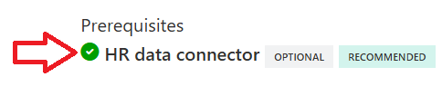
- Click Next.
- On the Name your policy page, name the policy DataSecurityCheck-DataTheft and provide a meaningful description.
- Click Next.
- Depending on the triggers that will be used for this scenario, select the users and/or groups to include.
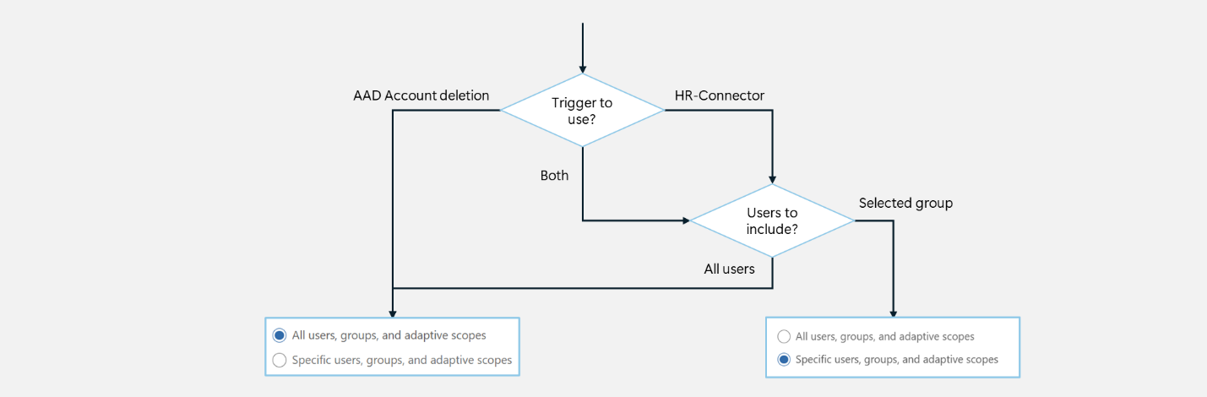

 Important
Users included in insider risk management policies must be assigned an appropriate (trial) license. Refer to Subscriptions and licensing for further details.

- Click Next.
- On the Exclude users and groups (optional) page, click Next.
- On the Decide whether to prioritize content, select I don’t want to prioritize content right now.
- Click Next.
- On the Choose triggering event for this policy page, below Choose triggering events, select one or both triggers, depending on customer preference:
  - (Recommended) HR data connector events
requires [Optional] Setup and configure a (simulated) HR-connector
  - User account deleted from Azure AD

Note
If you selected to include only <specific users, groups and adaptive scopes> when selecting the user scope, you will only be able to select to use the <HR data connector events>.

- Click Next.
- On the Indicators page, click Next.
- On the Detection options page, verify:
  - Under Sequence detections, all options are selected.
  - Under Cumulative exfiltration detection, all options are selected.
  - Under Risk score boosters, all options are selected.
- Click Next.
- On the Choose threshold type for indicators page, select Apply thresholds provided by Microsoft.
- Click Next.
- On the Review settings and finish page, click Submit.
- On the Your policy was created page, below Send me the following emails, verify When a new policy generates its first alert is selected.
- On the Policy was created page, click Done.

Note
After the policy is successfully submitted to the system it can take 24-48 hours before it becomes active.

[Optional] Instructions—enable device indicators

Instructions
If the customer opts in to enabling device indicators to further enrich detection capabilities of the General Data leaks policy, follow the instructions below.
- Follow the guidance in 1.2-Onboarding devices at the end of this document to enroll devices into the Microsoft Purview portal.

Update the Insider Risk Management policy to use device indicators
- Browse to the Microsoft Purview portal at https://purview.microsoft.com/ and log in with Tenant Admin credentials or a user account that is a member of your Data Security Check team and has been assigned the appropriate permissions.
- In the navigation bar on the left side, click on Solutions
- In the Solutions navigator, click on Insider Risk Management.
- On the Insider Risk Management solution card, click on Policies.
- On the Policies page, click on the DataSecurityCheck-DataTheft policy.
- On the DataSecurityCheck-DataTheft fly-out, click on Edit policy.
- On the Choose a policy template page, click Next.
- On the Name your policy page, click Next.
- On the Choose users, groups & adaptive scopes page, click Next.
- On the Exclude users and groups (optional) page, click Next.
- On the Decide whether to prioritize content page, click Next.
- On the Choose triggering event for this policy page, click Next.
- On the Indicators page, below Device indicators, click Select all or if needed, only select Device indicators that align with customer requirements, click Next.
- On the Detection options page, click on Next.
- On the Choose threshold type for indicators page, click on Next.
- On the Review settings and finish page, click on Submit.
- On the Your policy was created page, click Done.

Note
After the policy is successfully submitted to the system, it can take 24-48 hours before it becomes active.

Next step
- Return to the <00-Master Delivery Guide> and continue the guidance provided in Step 3 - Setup and configuration.

Step 4 - Analyze the findings
In this step the partner will, together with the customer’s tenant / compliance administrator, analyze all logs, information, and reports generated by the different Data Security Check tools and services. This section will describe the additional steps required to prepare and analyze the results from the Insider Risk Discovery.
It is recommended to do a two-step analysis of the logfiles, reports, and findings:
- Quick scan. By using the various dashboards and preview views, you will be able to identify common patterns and/or trends that need further investigation and can serve as an example of insider risks. Look for “most impactful” events related to important people within the organization, high volumes of documents related to a specific business process, Personally Identifiable Information (PII), etc.
- Detailed analysis using the exported log and report files for the various services will allow for further investigation of previously identified insider risks and events flagged during the quick scan. Aim at determining the impact and risk and consider viable solutions for mitigation that can be included to the close out presentation. During this detailed analysis, you are advised to leverage the insights of the customer team because they will know what and who to look for. To rule out “false positives”, you are advised to do further investigation of all the events that will be included in the final closeout presentation at the end of the engagement.

Prepare for analysis—exporting the reports and log files

Guidance
Insider Risk Management primarily offers a dashboard-based user experience to identify immediate, on-demand visual indicators of risk. Once risks are identified, they can be promoted to investigations. To provide uniform reporting, this report generation focuses on alerting results to identify highest-risk users and/or indicators that have a high correlation to identified insider risks.
Consider taking screenshots of the customer’s environment, if the guiding scope and customer context allow, to demonstrate to the customer how these risks are easily accessible to reviewing administrators.

Objective
- Export risks identified by Insider Risk Management for future analysis.

Background reading
For more information refer to:
- Investigate insider risk management activities

Prepare for analysis—Insider Risk Analytics

Instructions
- On the local workstation, if not already done, extend the previously created directory structure by creating the \DataSecurityCheck\InsiderRiskManagement folder.
- Browse to the Microsoft Purview portal at https://purview.microsoft.com/ and log in with Tenant Admin credentials or a user account that is a member of your Data Security Check team and has been assigned the appropriate permissions.
- In the navigation bar on the left side, click on Solutions
- In the Solutions navigator, click on Insider Risk Management.
- On the Insider Risk Management solution card, click on Reports.
- On the Reports page, click on Analytics.
- On the Results from the last scan for risk activities page, in the Potential data leak activities section, click on View details
- On the Potential data leak activities fly-out, take a screenshot of What we detected.
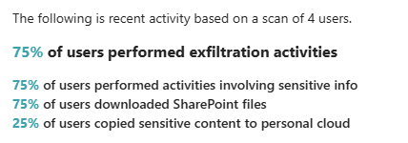

Note
Refer to Use Snipping Tool to capture screenshots for guidance on taking screenshots.

Note
Pay attention to the Recommendation on the <Potential data leak activities> fly-out, it provides information that can be useful for the recommendations section in the <41-Close-out deck>.

- Save the screenshot as <AnalyticsInsights-PotentialDataLeaks.jpg> to the previously created \DataSecurityCheck\InsiderRiskManagement folder for future use in the closeout presentation.
- On the Potential data leak activities fly-out, click Close.
- On the Results from the last scan for risk activities page, in the Top exfiltration activities section, click on View details.
- On the Exfiltration insights fly-out, take a screenshot of What we detected.
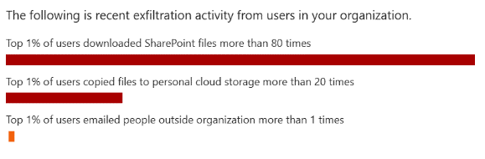
Note
Pay attention to the Recommendation on the <Exfiltration insights> fly-out, it provides information that can be useful for the recommendations section in the <41-Close-out deck>.

- Save the screenshot as <AnalyticsInsights-ExfiltrationInsights.jpg> to the previously created \DataSecurityCheck\InsiderRiskManagement folder for future use in the closeout presentation.
- On the Potential data leak activities fly-out, click Close.

Note
Depending on the user activity, additional Analytics insights might be available. It is recommended to also include these insights into the findings and recommendations section in the <41-Close-out deck>.

Prepare for analysis—Policies
- Browse to the Microsoft Purview portal at https://purview.microsoft.com/ and log in with Tenant Admin credentials or a user account that is a member of your Data Security Check team and has been assigned the appropriate permissions.
- In the navigation bar on the left side, click on Solutions
- In the Solutions navigator, click on Insider Risk Management.
- On the Insider Risk Management solution card, click on Reports.
- On the Reports page, click on Alerts.

Top countries/regions with alerts
- On the Alerts page, on the Top countries/regions with alerts card in the Demographics section, click on View Details.
- On the Top countries/regions with alerts page, above the graphic, click on Download to download the graphic.
- Save the screenshot as Top countries_regions with alerts.png to the \DataSecurityCheck\InsiderRiskManagement folder.
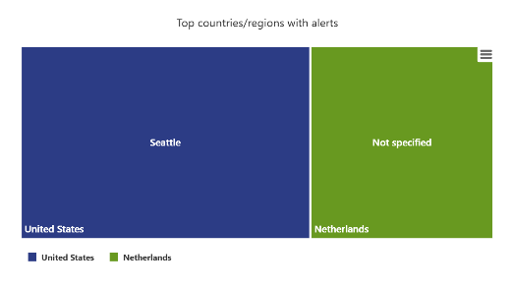
- Above the Details, click on Download to download a csv file with detailed information.
- Save the csv file as Top countries_regions with alerts.csv to the \DataSecurityCheck\InsiderRiskManagement folder.
- Click on Alerts in the navigation trail at the top of the page to return to the Alerts page.

Top departments with alerts
- On the Alerts page, on the Top departments with alerts card in the Demographics section, click on View Details.
- On the Top departments with alerts page, click on View by policy.
- Above the graphic, click on Download to download the graphic.
- Save the screenshot as Top departments with alerts.png to the \DataSecurityCheck\InsiderRiskManagement folder.
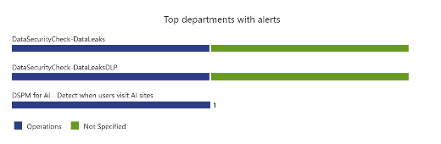
- Below Download alerts generated by department, click on Download to download a csv file with detailed information.
- Save the csv file as Top departments with alerts.csv to the \DataSecurityCheck\InsiderRiskManagement folder.
- Click on Alerts in the navigation trail at the top of the page to return to the Alerts page.

Alerts by top triggering events
- On the Alerts page, on the Alerts by top triggering events card in the Insights section, click on View Details.
- On the Alerts by top triggering events page, click on View by policy.
- Above the graphic, click on Download to download the graphic.
- Save the screenshot as Alerts by top triggering events.png to the \DataSecurityCheck\InsiderRiskManagement folder.
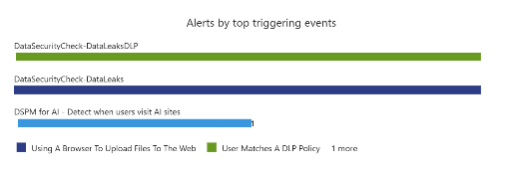
- Below Download alerts by triggering event, click on Download to download a csv file with detailed information.
- Save the csv file as Alerts by top triggering events.csv to the \DataSecurityCheck\InsiderRiskManagement folder.
- Click on Alerts in the navigation trail at the top of the page to return to the Alerts page.

Alerts by top activity that generated the alert
- On the Alerts page, on the Alerts by top activity that generated the alert card in the Insights section, click on View Details.
- On the Alerts by top triggering events page, click on View by policy.
- Above the graphic, click on Download to download the graphic.
- Save the screenshot as Alerts by top activity that generated the alert.png to the \DataSecurityCheck\InsiderRiskManagement folder.
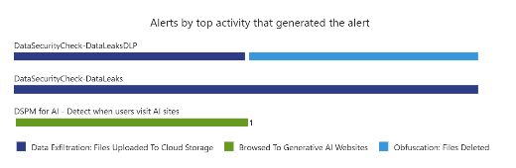
- Below Download alerts by activity, click on Download to download a csv file with detailed information.
- Save the csv file as Alerts by top activity that generated the alert.csv to the \DataSecurityCheck\InsiderRiskManagement folder.
- Click on Alerts in the navigation trail at the top of the page to return to the Alerts page.

Export Alerts
- On the Insider Risk Management solution card, click on Alerts.
- On the Alerts page, click Customize columns.
- On the Customize columns fly-out, at a minimum, select the following columns:
- Users
- Policy
- Time detected
- Triggering event
- Activity that generated the alert
- On the Customize columns fly-out, click Apply.
- On the Alerts page, click Export.
- Following the instruction provided in Appendix A of the Master Delivery Guide, open and format the downloaded Alerts _ Microsoft Purview.csv file located in the Downloads folder on your local workstation. The illustration below depicts a sample alerts export file.
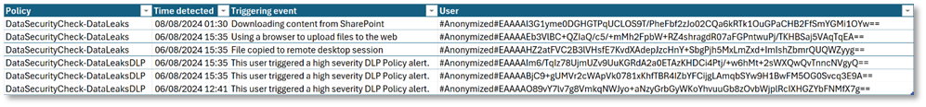
- Save the formatted CSV file as DataSecurityCheck-Alerts.xslx to the \DataSecurityCheck\InsiderRiskManagement folder on your local workstation.

Analyzing discovery findings log files for privacy and regulatory risks

Guidance
The Insider Risk Discovery findings are exported to DataSecurityCheck-Alerts.xslx The contents of this file, together with the screenshots, should be analyzed and copied to the placeholder slide in the <41-Close-out deck>.

Objective(s)
- Analyze the reports for the Insider Risk Discovery.

Instructions - DataSecurityCheck-Alerts
Filename | DataSecurityCheck-Alerts.xslx
Location | \DataSecurityCheck\InsiderRiskManagement
Contains | List of alerts for identified potential insider risk events, according to the thresholds and policies configured for insider risk:  - Policy that was triggered.  - Time detected.  - Triggering event.  - User (anonymized or identity, based on policy configuration).

Usage #1 | Provide an overview of users identified by Insider Risk Management who are engaging in behavior that could be harmful or impose risks to the organization.
Use in closeout deck? | YES
Instructions | - Open the previously created DataSecurityCheck-Alerts.xslx file.  - Create a pivot table matching the definition depicted in the illustration below.  - When creating the closeout presentation, copy the pivot table to the appropriate slide in the deck.
 | 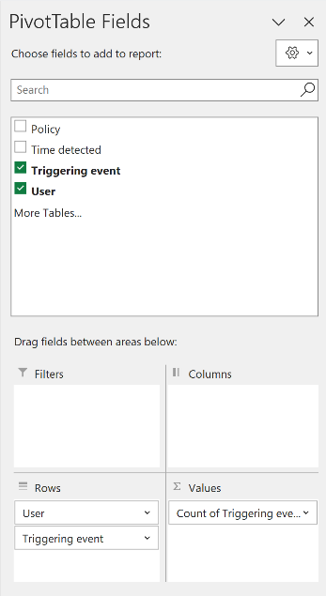 | Filters: Empty  Columns: Empty  Rows: User, Triggering event  Ʃ Values: Count of Triggering event  Sort: Descending (Z-A) Count of Triggering event
Sample illustration #1 | 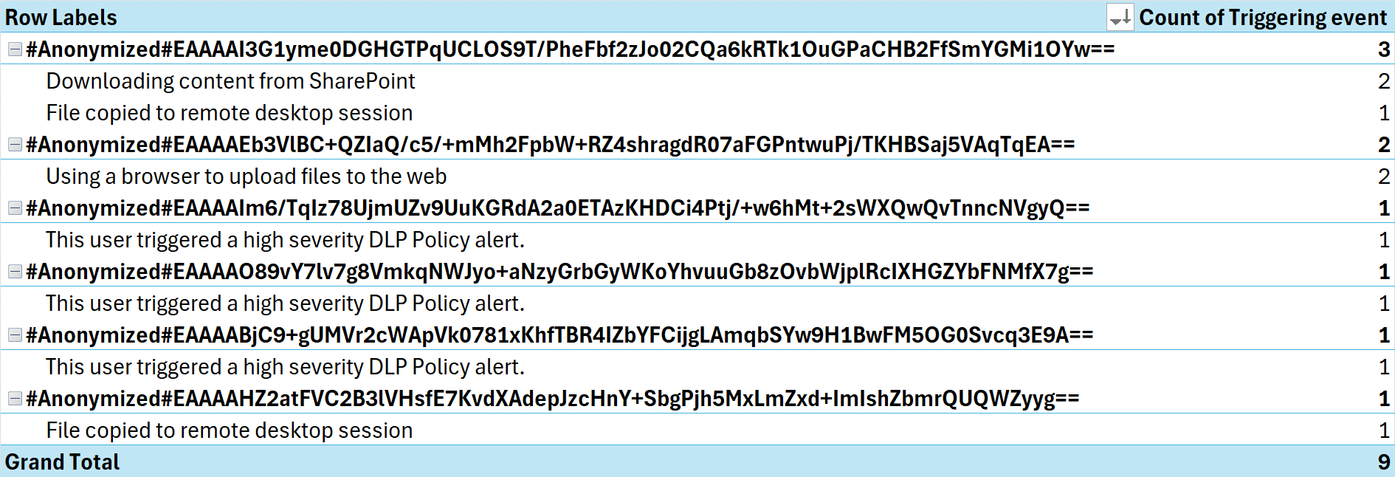

Usage #2 | Provide an overview of the types of events that are triggering insider risk detections.  Note  This data will be enriched when the customer has differentiated risk rules which correspond to DLP rules in the environment and recognize distinct types of risk concerns as different rules.
Use in closeout deck? | YES
Instructions | - Open the previously created DataSecurityCheck-Alerts.xslx file.  - Create a pivot table matching the definition depicted in the illustration below.  - When creating the closeout presentation, copy the pivot table to the appropriate slide in the deck.
 | 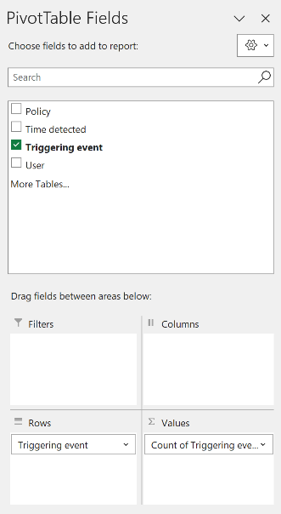 | Filters: Empty  Columns: Empty  Rows: Triggering event  Ʃ Values: Count of Triggering event  Sort: Descending (Z-A) Count of Triggering event
Sample illustration #1 | 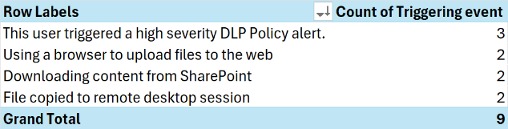

Next step
- Return to the <00-Master Delivery Guide> and continue the guidance provided in Step 4 - Analyze the findings.

Step 6—Decommission

Guidance
The final activity for the Insider Risk Discovery activity is to decommission the services and tools used for this activity.

Objective(s)
The objectives for this activity are:
- Decommission the services that were installed to support the Insider Risk Discovery.
- Delete all configuration artifacts used for Insider Risk Discovery.

Deliverable(s)
For this activity, the following deliverables have been defined:
- All tools and services used during the On-premises discovery are decommissioned.
- All custom configuration artifacts are removed from the customer’s tenant.

Instructions—Delete Insider Risk Management Policies
- Browse to the Microsoft Purview portal at https://purview.microsoft.com/ and log in with Tenant Admin credentials or a user account that is a member of your Data Security Check team and has been assigned the appropriate permissions.
- In the navigation bar on the left side, click on Solutions
- In the Solutions navigator, click on Insider Risk Management.
- On the Insider Risk Management solution card, click on Policies.
- On the Policies page, if it exists, select the DataSecurityCheck-DataLeaks policy and click Delete.
- On the Delete <policyname> pop-up, select Delete the policy and all associated alerts and users.
- Click Delete.
- On the Confirm you want to delete this policy and all associated alerts and users pop-up, click Confirm.
- Repeat the above steps for:
- The DataSecurityCheck-DataLeaksDLP policy
- The DataSecurityCheck-DataTheft policy

Instructions—Delete the Data Security Check HR connector
- Browse to the Microsoft Purview portal at https://purview.microsoft.com/ and log in with Tenant Admin credentials or a user account that is a member of your Data Security Check team and has been assigned the appropriate permissions.
- In the navigation bar on the left side, click on Settings.
- On the Settings card, expand Data connectors.
- Below Data connectors, click on My connectors.
- On the My connectors page, select the DataSecurityCheck-HRconnector and click Delete.
- On the Warning pop-up, click Delete.

Instructions—Delete the application secret for the HR connector application in Azure AD
- Browse to https://portal.azure.com/ and log in with your Tenant admin, Global admin, Compliance admin, or Data admin credentials.
- Navigate to the Microsoft Entra ID pane by typing Directory in the search box for resources, services, and docs and then select Microsoft Entra ID.
- Below Manage, click on App registrations.
- In the All applications section, click on the DataSecurityCheck-HRconnector
- Expand Manage in the left-hand menu.
- Below Manage, click Certificates & secrets
- In the Client secrets section, next to DataSecurityCheck-HRconnectorSecret, click to Delete the client secret.
- On the Are you sure…. popup, click Yes.

Instructions—Delete the Data Security Check HR connector application in Azure AD
- In the left-hand menu, click Overview.
- On the DataSecurityCheck-HRconnector overview pane, click Delete.
- On the Delete app registration flyout. click Delete.

Instructions—Delete the Data Loss Prevention policy
- Browse to the Microsoft Purview portal at https://purview.microsoft.com/ and log in with Tenant Admin credentials or a user account that is a member of your Data Security Check team and has been assigned the appropriate permissions.
- In the navigation bar on the left side, click on Solutions
- In the Solutions navigator, click on Data loss prevention.
- On the Data Loss Prevention solution card, click on Policies.
- Select the DataSecurityCheck-DLP-DataLeaks policy.
- Click Delete policy.
- On the Delete DLP policy popup windows, click Delete policy.

Instructions—Off board endpoints
- Browse to the Microsoft Purview portal at https://purview.microsoft.com/ and log in with Tenant Admin credentials or a user account that is a member of your Data Security Check team and has been assigned the appropriate permissions.
- In the navigation bar on the left side, click on Settings.
- In the Settings navigator, expand Device onboarding
- Below Device onboarding click on Offboarding.
- On the Offboarding page, below Select operating system to start onboarding process, select Windows 10.
- Below Deployment method, select Local script (for up to ten machines).
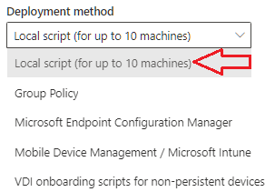
- Click on Download package. This will download the package as a zip file (DeviceComplianceOffboardingPackage_valid_until_YYYY-MM-DD.zip) to the default download folder.
- Copy the DeviceComplianceOffboardingPackage_valid_until_YYYY-MM-DD.zip file to the client workstation that has to be offboarded.
- Extract the contents of the configuration package (DeviceComplianceOffboardingScript_valid_until_YYYY-MM-DD.cmd) to a location on the device that needs to be offboarded.
- Go to Start and type Cmd.
- Right-click Command prompt and select Run as Administrator.
- Browse to the location of the script file.
- Run DeviceComplianceLocalOnboardingScript_valid_until_YYYY-MM-DD.cmd.
- Verify the script completed successfully.
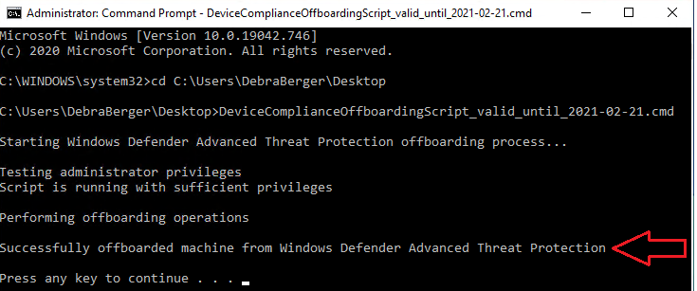
- Close the command prompt.

Note
For additional information on offboarding devices refer to Offboard Windows devices.

Instructions—Turn off device monitoring
- Browse to the Microsoft Purview portal at https://purview.microsoft.com/ and log in with Tenant Admin credentials or a user account that is a member of your Data Security Check team and has been assigned the appropriate permissions.
- In the navigation bar on the left side, click on Settings.
- In the Settings navigator, expand Device onboarding.
- Below Device onboarding click on Devices.
- On the Devices page, click on Turn off Windows device monitoring.
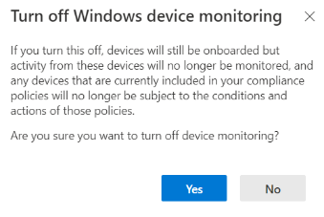
- Click Yes.

Instructions—Remove role assignments for the Data Security Check team members
- Browse to the Microsoft Purview portal at https://purview.microsoft.com/ and log in with Tenant Admin credentials or an account that is assigned the global admin role.
- In the navigation bar on the left side, click on Settings.
- On the Settings card, expand Roles and scopes.
- Below Roles and scopes, click on Role groups.
- On the Role groups for Microsoft Purview Solutions page, search for for Insider Risk.
- In the navigation pane on the left side, under Roles & Scopes click Permissions.
- On the Permissions & Roles pane, below Microsoft Purview solutions click on Roles.
- On the Permissions > Role groups for Microsoft Purview solutions pane, search for Insider Risk.

- Click on Insider Risk Management.
- On the Insider Risk Management fly out, click Edit.
- On the Edit members of the role group page , select all the Data Security Check team members that were assigned the Insider Risk Management role.
- Click Remove members.
- Click Next.
- On the Review the role group and finish page, click Save.
- Click Done.

Next step
- Return to the <00-Master Delivery Guide> and continue the guidance provided in Step 6 - Decommission.

- Enable device indicators
To detect activity on devices, devices must be onboarded to the Microsoft Purview portal and device indicators should be selected for the Insider Risk Management policy. This paragraph provides instructions to onboard devices to the Microsoft Purview portal.
  - Endpoint requirements
Devices can only be onboarded to the Compliance Center if they meet all the following requirements:
 Important
The list of pre-requisites is frequently updated, so before engaging on this activity, check the information outlined in Onboard Windows devices into Microsoft 365 overview.

- Verify the devices that are targeted for onboarding meet the minimum requirements as outlined on Prepare your Windows devices

  - Onboarding devices

Guidance
To use Device indicators, devices must be onboarded to the Microsoft Purview portal.
Devices that have already been onboarded to Microsoft Defender for Endpoint or Data Loss Prevention for Endpoints will automatically appear in the managed devices list and do not require additional onboarding. To onboard devices that have not been onboarded yet, an onboarding script needs to be downloaded and deployed to these devices.
The illustration below provides a high-level overview of the different methods of onboarding devices to the Microsoft Purview portal.
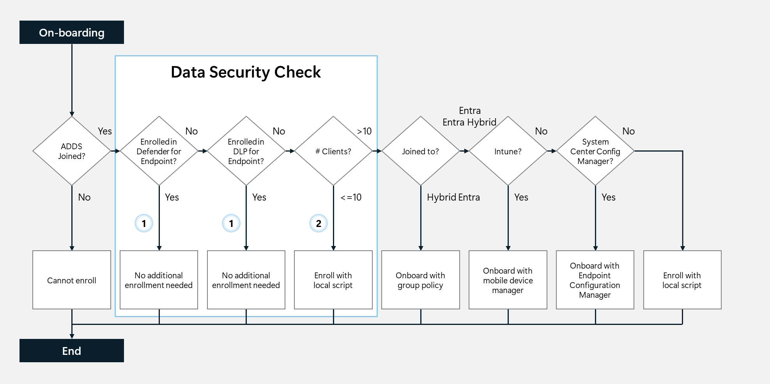
This guide will provide onboarding instructions for:
Option : Endpoints already enrolled in Microsoft Defender for Endpoint or Data Loss Prevention for Endpoints.
Option : Endpoints that will be enrolled through the execution of a local script.
For all other onboarding options, refer to Onboarding Windows 10 or Windows 11 devices

Objective(s)
- Enable Device indicators for Insider Risk Management policies.

Background reading
- Windows 10 and Windows 11 Onboarding procedures
- Onboard Windows devices into Microsoft 365 overview

Instructions - Option - Verify endpoint is enrolled in the Microsoft Purview portal
Endpoints that have onboarded to Microsoft Defender for Endpoint will appear in the managed devices list. These devices are already reporting in, and no further onboarding action is required.
To understand and verify which devices are onboarded, follow the steps outlined below:
- Browse to the Microsoft Purview portal at https://purview.microsoft.com/ and log in with Tenant Admin credentials or a user account that is a member of your Data Security Check team and has been assigned the appropriate permissions.
- In the navigation bar on the left side, click on Settings.
- On the Settings card, expand Device onboarding.
- Below Device onboarding click on Devices.
- Verify the devices that will participate in the Data Security Check are listed on the devices overview.

Instructions - Option - onboarding Windows 10/11 devices using a local script
For customers not using Microsoft Defender for Endpoint or devices that have not (yet) been onboarded, the endpoint must be onboarded before device indicators can be used as part of the Data Security Check. This section will describe the steps to onboard Windows 10/11 devices by executing a local script.
Note
Onboarding devices by using a local script is optimized for onboarding one to ten devices. For alternative onboarding methods, refer to Windows 10 and Windows 11 Onboarding procedures.

- Browse to the Microsoft Purview portal at https://purview.microsoft.com/ and log in with Tenant Admin credentials or a user account that is a member of your Data Security Check team and has been assigned the appropriate permissions.
- In the navigation bar on the left side, click on Settings.
- On the Settings card, expand Device onboarding
- Below Device onboarding click on Devices.
- If device onboarding has not been enabled yet, click Turn on device onboarding.
- On the Turn on device onboarding pop up window, click OK.
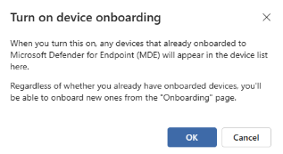

Note
Turning on device onboarding will take time, refresh the page to check progress.

- On the Settings card, below Device onboarding click on Onboarding.
- Below Select operating system to start onboarding process, select Windows 10.
- Below Deployment method, select Local script (for up to ten machines).

- Click on Download package. This will download the package as a zip file. <DeviceComplianceOnboardingPackage.zip> to the default download folder.
- Copy the <DeviceComplianceOnboardingPackage.zip> file to the client workstation that has to be onboarded.
- Extract the contents of the configuration package <DeviceComplianceLocalOnboardingScript.cmd> to a location on the device that needs to be onboarded.
- Go to Start and type Cmd.
- Right click Command prompt and select Run as Administrator.
- Browse to the location of the script file.
- Run DeviceComplianceLocalOnboardingScript.cmd.
- Enter Y to confirm.
- Verify the script completed successfully.
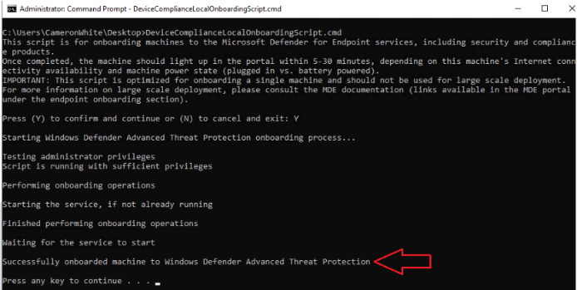
- Close the command prompt.
- Follow the instructions outlined above (Instructions - Option - Verify endpoint is enrolled in the Microsoft Purview portal) and check if the device is listed in the Devices overview.

Note
It may take 5-30 min before a newly onboarded device is visible in the Devices overview.

- Enable Data Loss Prevention triggering
Follow the instruction below to enable Data Loss Prevention as a trigger for Insider Risk Management policies by creating a high severity Data Loss Prevention policy.
 Important
The high severity Data Loss Prevention policy will include the Sensitive Info Types that are created in the <00-Master Delivery Guide>. Make sure the Custom Sensitive Info Types are configured before creating the Data Loss Prevention policy.

Guidance—Create a Data Loss Prevention policy
Insider Risk Management leverages Data Loss Prevention policies to help identify the intentional or accidental exposure of sensitive information to unwanted parties. When configuring an Insider Risk Management policy with the General Data leaks template, a specific Data Loss Prevention policy must be assigned to the Insider Risk Management policy. This policy helps drive the alert indicators for sensitive information and is an important part of configuring full risk management coverage in an organization. Because of the 1:1 relation between a General Data leaks and a Data Loss Prevention policy, an implementation containing multiple Data Loss Prevention policies would require the same amount of Insider Risk Management Policies to be implemented.
Note
To avoid the need for creating multiple Data Leaks policies, we will create a single Data Loss Prevention policy that includes all Sensitive Info Types to be monitored.

This paragraph describes the steps to create a Data Loss Prevention policy that includes all the Sensitive Info Types, both custom and out-of-the-box, that the customer has previously identified as of interest.

Objective(s)
- Create a Data Loss Prevention policy to be used by Insider Risk Management.

Background reading
For more information and further customization, refer to:
- Configure Data Loss Prevention (DLP) policies

Instructions
- Browse to the Microsoft Purview portal at https://purview.microsoft.com/ and log in with Tenant Admin credentials or a user account that is a member of your Data Security Check team and has been assigned the appropriate permissions.
- In the navigation bar on the left side, click on Solutions
- In the Solutions navigator, click on Data loss prevention.
- On the Data Loss Prevention solution card, click on Policies.
- On the Policies page, click + Create policy
- On the Choose what type of data to protect page, select Data stored in connected sources.
- Click Next.
- On the Start with a template or create a custom policy page, below Categories, select Custom.
- Below Regulations, select Custom policy.
- Click Next.
- Type DataSecurityCheck-DLP-DataLeaks as the name of the new policy and provide a meaningful Description.
- Click Next.
- On the Assign admin units page, click Next.
- Under Choose locations, verify the following locations are selected :
  - Exchange email
  - SharePoint sites
  - OneDrive acounts
  - Teams chat and channel messages
  - Devices (optional)
- Click Next.
- On the Define policy settings blade, select Create or customize advanced DLP rules.
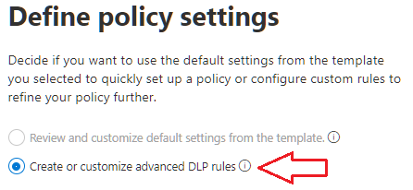
- Click Next.
- On the Customize advanced DLP rules page, click +Create rule.
- Type DataSecurityCheck-DLP-DataLeaksRule as the name of the new rule and provide a meaningful Description.
- Below Conditions, click on +Add a condition, select Content contains.
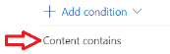
- Click on Add and select Sensitive Info Types.
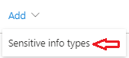
- On the Sensitive info types page, search for DataSecurityCheck- and select all Custom Sensitive Info Types identified by you and your customer during the Pre-engagement meeting or Kick-off meeting.
Note
The Custom Sensitive Info Types can be easily identified by searching on the <Publisher> name or by searching for <DataSecurityCheck->.
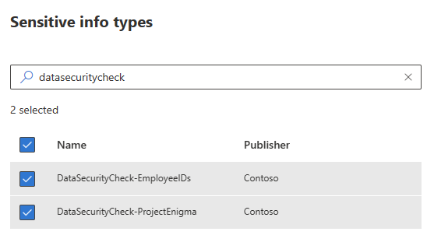

- Select all previously identified Out-of-box Sensitive Info Types that align with your customer’s situation.
- Click Add.
- Back on the Create rule page, Below Group operator, verify Any of these is selected.
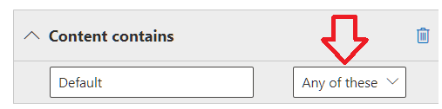
- Below Incident reports, select High as the severity level and disable Send an alert to admins when a rule match occurs.
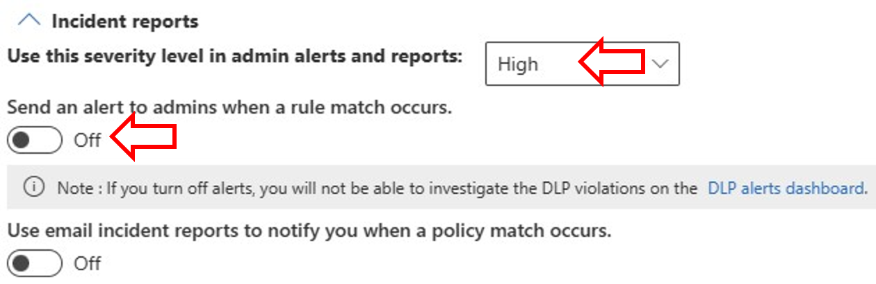
 Important
The Incident reports rule setting in the DLP policy used for the Insider risk management template must be configured for High severity level alerts. The High severity level is the triggering event and insider risk management alerts will not be generated from rules in DLP policies with the Incident reports field set at Low or Medium.

- Click Save.
- Back on the Customize advanced DLP rules page, click on Next.
- On the Test or turn on the policy blade, select Turn the policy on immediately.
Note
It can take up to one hour for the new policy to go into effect.

- Click Next.
- Review your settings and then click Submit.
- Click Done on the New policy created confirmation page.

